**About Eco-Point**

Eco-Point develops and produces ecological and sustainable cleaning and maintenance solutions for industry. Our sustainable products are developed and designed to remove contamination effectively and safely, such as grease, limescale, glue, ink, rust and paint etc. All products are manufactured in our facility in The Netherlands.

We started over thirty years ago as sustainability pioneers; with one goal only, to contribute to a cleaner, environmentally friendly, and safer world. Obviously cleaner through the outstanding performance of our products, environmentally friendly because of the upcycling of residual flows of i.e., sugar beet, maize and rutabaga or rapeseed and safer because of the lack of hazard symbols on our products.

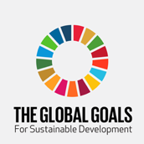

**Our Sustainable Development Goals (SDG)**

By working with Eco-Point products, you contribute to 5 out of 17 Sustainable Development Goals set by the United Nations.

These are:

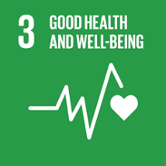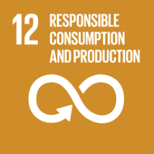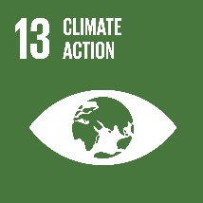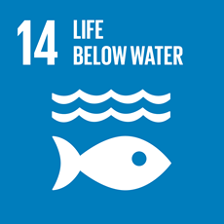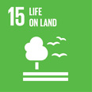

**13/15 Climate Action & Life on Land:**

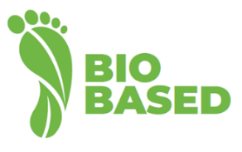**Working with renewable resources**

Our ambition is to reduce the scope of the resource flows and reuse materials as much as possible. Wherever this is not possible, we want to separate resource flows, so processing has a minimal impact on the environment.

We want our company activities to contribute to a cleaner world for future generations and in this way be part of sustainable chains. We consider investing in sustainability an important condition for continuity: for our own organization, but also for those of our clients.

Eco-Point products are high quality products. High quality means reliable, sustainable and safe, both in production as well as for end users. We work based on residual flows of sugar beet, maize, and rapeseed, which are upcycled into products that do not require hazard symbols. They become Hazard Symbol Free.

We focus on the creation of Hazard Symbol Free products. Quality & Safety are our priority. Day in day out.

**3 Good Health and Well-Being:**

At Eco-Point we make the world a cleaner place. That is necessary too. Sustainability, hygiene, and safety are not self-evident. As a producer of excellent sustainable cleaning solutions, we make a positive contribution to this every day. That's why we say: “*we are conscious people helping conscious people”*. That is our purpose. We help our customers to consciously choose efficient products with a positive impact on people and the environment. We work on the basis of natural resources and always with sustainability as a vision. It is not without reason that we say: “*by nature, for life*”. Together with our partners, we work, day in and day out to achieve a clean, sustainable and safe environment. In everything we do, quality and safety for people, the environment and materials are of the utmost importance. In this way we make cleaning work more pleasant, while we contribute to a clean world.

**Hazard Symbol – Free maintenance and cleaning products**

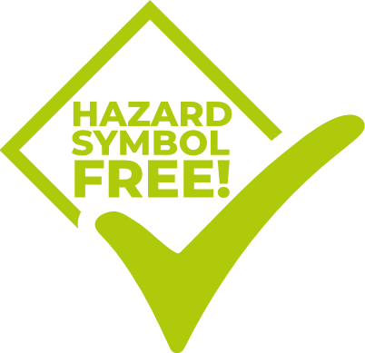Products containing hazardous substances have hazard symbols and other warnings on their labels. They indicate the danger that could occur if you use the product incorrectly. A substance may be irritating or corrosive, harmful to people and the environment, or flammable or explosive. Some symbols may appear in combination on the same product. Hazard Symbol-Free means that the product does not require any hazard indication (symbol) or warning and therefore no hazard symbol is needed. With that the product is safe for humans and the environment.

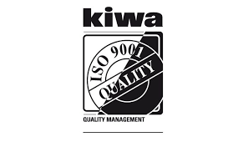**12 Responsible Consumption & Production:**

**ISO 9001 - 14001**

The multitude of components in the recipes requires great care to achieve our high-quality requirements. In addition to the ISO 9001 certificate (quality management) Eco-Point also holds the ISO-14001 certificate (environment policy). Each year our management and employees determine objectives. Interim measurements are also conducted and possible adaptations take place. These objectives often have a CSR character such as propagating CSR principles, participation in work group bio-based economies and further research into certification opportunities for Eco-Point cleaning products. Every year we are audited by the independent KIWA institute.

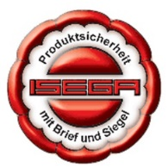**ISEGA certificates**

Various Eco-Point products have an ISEGA certificate. ISEGA is an independent German test institute that tests the compliance of all forms of packaging materials within the food industry. The ISEGA test reports and conformity certificates are well respected at both national and international levels by governments and trade. It is meant to ensure that there is as little risk of contamination as possible in the production process of all food products. This also includes the cleaning aspects; therefore, Eco-Point has various products in its range that are consistent with this and are certified for use in food and adjacent industries.

Products with the ISEGA certification can fulfil an essential task for food producers and adjacent companies that have to work according to the H.A.C.C.P. guidelines. Pollution is a “critical point” and must be constantly controlled. ISEGA certified products contribute to a controlled working environment.

**Regeneration**

Regenerating (or perhaps recycling of solvent recycling?) means processing waste materials in such a way that they can be reused. An extremely sustainable process because the reuse of solvents and cleaning agents saves the environment. Regeneration is a solution for sustainable organizations that want to reduce waste in the cleaning process. For a couple of years, Eco-Point has built up a regenerating program that benefits our customers financially but more importantly benefits the environment on a broad set of topics.

**Responsible production**

Our production facility in Halsteren, The Netherlands works cleanly and safely. Performance indicators ensure a constant improvement in our process. The production is a mixing process based on formulas, after which the filling is done in the various forms of packaging. The storage of resources is partly underground, after which pumps ensure that the liquids are transferred in precise doses into the large mixing tanks. Next the process of weighing, mixing, coloring and thickening can start.

Eco-Point uses green electricity from solar panels, green gas and separated waste flows for e.g. paper and other waste.

Eco-Point mainly produces and transports concentrates. These concentrates can be diluted with water by our customers. This reduces the cargo space required and hence energy, costs and CO2 emission. By making use of existing technologies, the dilution process with water can also be conducted without using electricity.

**Packaging**

Eco-Point packs its products in metal (drums) or in polyethylene high-density (HDPE). We accept the return of empty packaging free of charge for recycling or reconditioning. When incinerated polyethylene has no harmful effect on the environment.

Eco-Point spray bottles are PE bottles, which are: lightweight, use few resources are per package, consume small amounts of energy during production, virtually unbreakable for a longer life span, generate small amounts of waste during production and later recycling, contain no harmful substances when incinerated and are 100% recyclable. These bottles are fitted with a wide base for stability and a handy measuring scale.

**14 Life below water:**

With our broad base of ‘marine’ partners, we’re focused and specialist in cleaning solutions that preserve our largest ecosystem, the oceans.

